FINAL REPORT

Matra European Partnership Programme

Project name:

Strengthening the capacities of local communities to influence and control the implementation of reforms in agriculture, land management and rural development

Draft of 2017 April 11th

(Abbreviation and popular work-name is: BELIEVE)

Reporting period: December 2015 – February 2017
Organisation: International NGO Primavera
Date of report: 2017 March 4th
Duration of project: December 2015 – February 2017

- Context of activity/programme at the outset

The project is prepared and implemented under the Matra European Partnership Programme 2015 of the Netherlands.

- The context, goals, target groups, results, activities etc. are described in two parts:

A. the original application of October 2015 and B. some adaptations in the Elaboration plan of December 2015

- General objectives and target groups

Project Goal: :
Further, broader dissemination and implementation of the principles of Good Governance in the fields of Land Reform and Rural Development

Target groups:

- Several Ministries (primary MAPF), Agencies, Cabinet of Ministers, Parliament, (international) donors, Press, NGO’s.
- Public Platforms in
- 1. Fastiv district in Kiev Oblast,
- 2. in Belozerskiy district in Kherson Oblast,
- 3. in District Bela-Tserkva of Kiev Oblast, and districts in
- 4. Lviv,
- 5. Volyn, and
- 6. Poltava Oblast
- NGO Primavera has further developed a National Network between these 6 PP’s and the involved other NGO’s , to support and train the existing and new PP’s.
- NUBIP University Kyiv and National University on water economy and environment protection in Rivne are approached to play a role in the broad dissemination of the results of the project in their Bachelor and Master courses

- Interim and final goals defined at the outset:

The sub-goals under the Project-goal are :

a. develop and strengthen capacities of local communities and civil society organizations that were developed in the previous Matra project on “Good Governance in the fields of Land Reform and Rural Development” and dissemination and enhancement of their experience to new Oblasts and Districts by establishment of several new Public Platforms
b. create a supportive network between the existing and new PP’s for exchange and learning from each other;
c. build capacities of the NGO Primavera by selection and involvement of new local leaders and public platform’s members to influence and act on the local and national;
d. create of National Public Platforms Network that will join civil society, government authorities and Parliament committees, for establishment of a permanent dialogue between civil society and government
e. organise a Train-the-Trainer program for local leaders, to develop new and strengthen existing Public Platforms. f. Exchange the experiences of the existing and new PP’s, learn from each other, + control / monitor government and develop new tools of Influencing, support MAPF (and Parliament) in implementing and monitoring of several recommendations in the MAPF – Strategy for Agriculture and Rural development, by means of social dialogues
g. focus in all activities on ‘change-making potential and potentials’
h. organise a study-tour of a selection of 2 persons per PP, to NL
i. organize of , permanent dialogue between GOV and civil network j. develop further the website of the Matra-1 project : www.goodgovernance.org.ua
k. boost the role of women in politics and leadership in these fields (among others by ‘in principle’ equal representations of males and females in the PP’s)

- Planned activities
Detailed description of planned activities and their objectives

1. Final selection of new regions and districts / communication with Regional and district authorities, local potential RD leaders in these new regions and districts ( Bela Tserkva district in Kyiv oblast; districts in Lviv, Volyn and Poltava oblasts.) about their leadership for development of new public platforms and presenting for them the experiences of previous Matra project
2. For two existing PP’s in Fastiv and Belozerska districts facilitation in elaboration of their 2 x 2 project proposals and develop new additional proposals, in the framework of the Ukr / NL Program of Cooperation, by the Dutch Agency RVO
3. The members of these two PP’s will be invited to participate in a Train-the-Trainer program, to transfer experiences with the four new to be established PP’s
4. Organise a study-tour for 2 people from each public platform and representatives from NGO and Ministry of agrarian policy (3) to the Netherlands to learn from Dutch experience on Good governance and development of RD projects
5. In each of the Oblasts Kiev and Kherson will be selected and established a new PP (preferably on District level)
6. In each of the 4 new pilot areas in different regions (Lviv, Kyiv, Volyn, Poltava, Kyiv) will be selected and established a new PP (preferably on district level)
7. The four new PP’s will be supported by means of a starting workshop in Kiev, to discuss the experiences of the existing 2 PP’s, to make-up their own mind about their position and future, and to compose an Action-plan per PP. Further elaboration of these Action-plans will take place outside the scope of Matra, so on their own initiative. Within this new Matra project it will be organized, beside the Kiev starting workshop, only one workshop per region and all other local actions will be organized by Local leaders, ’only with ‘distant coaching’ by the NGO.
8. NGO Primavera will invite members of PPs to join the NGO and develop a ‘National Network” between the 6 PP’s and other NGO’s, press etc., to inspire and support each other permanently, and use therefore a.o. the existing Website, and all available social media
9. All 6 PP’s will be involved in commenting and monitoring of selected points from chapter 7.1 and 7.3 from the MAPF-Strategy on Agriculture and Rural Development. This will lead to a separate and concrete written advice to MAPF and SGC
10. Organize via the established PP Network a dialogue between government and civil society on land management and RD issues. Use a Parliament Committee as a place for the life meetings between government and PP network with broad involvement of press; this will happen during the Matra project in total 3 times
11. Organise half-way and at the end of the project National Seminars, (so in total 2) about the results of the project, with broad exposure / representation of TV, radio and written press.

The concretely realised activities in the whole project have been extendedly reported and illustrated in the Progress report per 2017 February 1st , that is added as Annex 1 of this Final report.

- Further information as far as different to planned activities or problems identified

Train the trainer :
The coachings of the 6 Public Platforms by NGO Primavera and by the Dutch Enterprise Agency RVO have supported the awareness and skills of the members of the Public Platforms. Subsequently the members of the Public Platforms have organised own workshops with other local entrepreneurs and officials to develop the initiated rural development business projects further and to start new initiatives. The PPs organized several exchange visits to learn from each other and share existing problems and possible solutions. Representatives from MAPF RD department participated in several local and national workshops and presented requirements on formulation of project proposals from the pilots to submit their proposals for financing by the government program of the Ministry of Regional development in the framework of the decentralization process.
But it is not possible to have government support for those communities that don’t like to follow government recommendations about merging with each other for creation of bigger administration boards of village councils and still prefer to work as they are or like to merge only according to their own vision. Beside, the majority of the government funds to support RD programs focused only on funding the measures about social infrastructure of the villages (roads, schools, lightening, health care, sport etc). The pure economical projects that focus on the development of business and entrepreneurship activities and cooperation between big and medium and small farmers are not supported from this program of the Ministry of regional development. An other important problem is that PPs have, although they were trained by NGO and NGO, still not enough capacities to formulate and submit by themselves project proposals for existing government and donor projects. For such work they need to have support from the Oblast authorities and involvement of a special expertise as well as some ‘seed money’ for organizational costs. This problem is not always connected with lack of knowledge but also with lack of time for more detailed elaboration of project documents according to the specific requirements of different financial organizations and programs. A special capacity building program needs to be introduced on the national level to support first steps of formulation and submission the local project proposals. The additional support will be needed also for organization of co-financing mechanism for projects implementation.

National Network of Public Platforms :
The 6 Public Platforms have already taken several initiatives to visit each other and to join forces. This is the basic start of the National Network. The Ukrainian Association of local governments has attended the Final Matra Seminar and will publish the Matra Brochure on their national website which will be read by all local members of the Association. Additionally the Matra Brochure ( annex will be sent to all other Oblasts, beside the 5 that were already represented in the 6 Public Platforms, also to put the Matra Brochura on the websites of all Oblasts. This could lead to more local initiatives to start Public Platforms when special supportive capacities will be created on the national level by the government education programs for rural communities and introduction of first step “seed-funding” program to support the organization of the local initiatives, leader groups and experts in rural areas for formulation and submission of the business project proposals for different type of funding..

Halfway seminar.
In accordance with the Embassy is decided to not hold the halfway Seminar, because of the limited mandays for the Matra project, and because then all attention could be put to reach a broad audience in the Final Seminar.

- Further information if different from planned over the implementation period, which are additional to the original project description.

Extra Training :
During the project NGO Primavera with her experts has trained the Public Platforms in many aspects and initiatives, like : awareness to take own local initiative, stimulating self-believe, organising local workshops, selecting, initiating and elaborating 2 local rural developments projects per Public Platform, professional project management, approaching project partners and co-financers, and formulating proposals for concrete changes in the Reform processes.
Beside, during the Study tour in the Netherlands in June 2016 and during an extra Project management Training in Kiev in October 2016, the Dutch Enterprise Agency RVO was motivated and willing to give additional training. RVO has supported and broadened the training of the Public Platforms on especially further professional project management.

12 local rural development business projects :
The Public Platforms are stimulated and were/are very motivated to go further than only initiating 12 local projects, but also have used the opportunity to elaborate their 12 project plans as far as possible. A number of local initiatives have been implemented by the PPs on their own costs and with support of local budgets. (Irrigation restoration on an area, design project on river restoration for a recreation project, development of a logistic network for selling the local products, development of new touristic program and advertisement of it etc.). Beside, some of the PPs managed to submit their proposals to different donor projects (USAID , French program etc). All 12 project proposals were disseminated around donor projects and were also sent to MAPF. The first results on elaboration and implementation of 12 projects were presented during the Final Matra seminar. In Annex 3 there are 6 Power point presentations of these 12 projectpresentations

Cooperation with regional and districts authorities
The Memorandums of cooperation were signed with district and oblast administrations and councils. The information about project activities and events was permanently presented on the web-sites of oblast and districts administrations. Representatives from Volyn and Lviv Oblast departments were the most active supporters of their projects.

Communication with MAPF and Parliament to monitor the Reform processes:
During the project nice contacts and sharing of information were organized between NGO Primavera and the RD department of MAPF. The Public Platforms have formulated their recommendations for several Reform processes in concrete letters and documents that were sent to the main Heads of Department of the Ministry for Agrarian Policy MAPF and to the Agrarian Committee of the Parliament. The recommendations were focused on support of cooperatives, promotion of land reform, creation of water user’s organizations, changes in taxation system etc.... The PPs and NGO Primavera have several times communicated with MAPF via official and informative letters and received important responses. The special monitoring sessions were organized in MAPF in July 2016 with participation of a number of departments of MAPF. Representatives from the 6 PPs could ask direct questions about reform process, announced remarks and recommendations from pilots and raised the most painful not solved problems. The PPs recommendations were presented on several meetings of MAPF with donor organizations and communicated during the meeting with the deputy ministers of MAPF Mrs Olena. Kovalova and Mrs. Olga Trofimtceva
Several meetings with representatives from 6 PPs and Parliament members were organized to present and have response on recommendations that were sent to the Parliament committee. The official responses were received from them to NGO Primavera with words of support and invitation for further cooperation.

Open Letter :
At the Final Matra Seminar on 2017 February 22nd, where The Dutch Ambassador Klompenhouwer and the Ukrainian deputy Minister Kovalova has spoken, the Public Platforms have used the opportunity the put and discuss concrete questions to the Dep Minister, and to offer an Open Letter with the most important statements and proposals to MAPF and Embassy. ( Annex 3)

New project idea :
Further the Public Platforms, supported by NGO Primavera, have formulated a new, broad project idea for a EU-funded “Integrated, territorial, rural development (LEADER-like) project”, with the 6 Matra areas and more. This will be elaborated by a Consortium of NGO’s, like a.o. GoLocal ad Primavera in cooperation with the Ukr Chamber of Commerce. ( Annex 4 )

- Your assessment of the activities / programmes

NGO Primavera is very thankful to the Dutch Embassy that this Matra project has been possible. This thankfulness is expressed as well in public very clear during the presentations of the Chairpersons of the 6 Public Platforms to MAPF and Embassy

NGO Primavera is satisfied and proud about the attitude of the Public Platforms, who started this Matra project very much doubting about their own self-believe and possible initiatives and influence. During the workshops and training and personal contacts of the project their self-believe has developed substantially. Their success with initiating and developing their 12 projects has been clearly beyond their expectations.
The Study tour has been very many-sided and inspiring for the Public Platforms. Not only to make acquaintance with several Dutch organisations and Dutch governmental and business ‘players’ in the rural area, but it appeared also an eye-opener for them about the openness-, cooperation- and win/win- attitude in the Dutch society.

The recommendations of the 6 PP’s for several Reform processes not only been discussed with MAPF and Parliament, but have also been input, via NGO Primavera, during the whole project periods in several Workings Groups under MAPF.

NGO Primavera requests for more and continued support from MAPF and the NL Embassy, esp. for developing together of the proposed new project : a EU-funded “Integrated, territorial, rural development (LEADER-like) project”.

- Interim and final goals achieved.

- Further information if they do not correspond to the problems identified/planning:
Two public platforms in Fastiv Kyiv oblast and Belozerskiy district in Kherson oblast are invited to cooperate within a new NGO project on Land consolidation that started in January 2017 under a FAO/TCP project between MAPF, StateGeoCadaster.. The local land users and landowners as well as village councils will participate in testing of the draft Land consolidation Law , as developed by SGC and also in a Feasibility study for formulation of Land consolidation pilots that will support development of agriculture and other business in rural areas, that are corresponded directly to the projects formulated during ‘Believe” project of Matra program.

- Have the overall goals been achieved?
Yes. for sure, even beyond expectations : The Public Platforms have become self-believing and initiating above their own expectations. Their own initiated and elaborated 12 projects has been developed further that they expected before.
At the end of the project the PP’s have realised that they have to keep-on and ‘fly-on-their-own’ further without and after Matra. We can say that the “Believe” project has provided significant investments in development of human potential of the rural communities in the pilots, in view of : knowledge dissemination; awareness rising; introduction of integrated territorial planning approach; development of cooperative tolerant behaviour and how to reach “win- win” solution; development of organizational skills to establish dialogues and communications between different partners on the local, regional and national level: creation of goal oriented self-management culture and understanding of own responsibilities for implementation of reforms and development of rural areas.
The project has even implemented much more activities thanwere planned at the beginning but looking on the general process in political arena and reform implementation on the national level it is clear that the new bottom- up approach and further spreading of good governance within all type of organizations and projects should be a main attention point to speed reforms further and control the government activities. Therefore, introduction of Leader approach in Ukraine will be the very important next step because that will help to make a strong link between further strengthening of civil society activities and economic developments.

- Has the target group been reached?
All concerned, important local stakeholders have been reached.
Attention and further action points:
Active supporting of the 12 PP’s and their 12 projects should be continued by MAPF further, this asks for permanent attention and ‘knocking’ at the doors of MAPF and donors.
The commitment of State Geo Cadaster (Land Reform) could have been better.

- Conclusions with regard to the skills of the implementing body:
NGO Primavera has done a very stimulating and motivating job to let the PP members grow in their self-believe and influencing role; this was done beside the management of this urgently needed, complex project. NGO received a new unique experience in working simultaneously with many organizations on the national level, regional and local level. Such experience of NGO Primavera and other NGOs that work now in the same type of international projects is very vital for government to bridge society and government, that
authorities will have better hearing of their population and understanding of its real problems, deep reasons and motivations during processes of policy development and implementation. Such type of skills needs to be openly recognized by government to use NGOs as an important player during implementation of reforms. Their human oriented open mind and tolerant approach with big positive energetic mood is not less important than technical knowledge and economic calculations. Therefore, NGOs activities and their role need to be recognized more by the national, regional authorities as well as by local communities and business. Ukrainian society needs to come to new approaches when importance of involvement NGOs can be recognized by both parties: government and local communities. NGO activities need to be supported by state budget and local budgets and business. For now the majority of the NGOs project are financed via international donor organizations and not by government. NGOs services are much more flexible cheap and more close to the people than official bureaucratic way of working of authorities.

- Further comments on the above conclusions:
Suggestions for future lessons to be learned:
Such a project was very necessary and this calls for many more of such projects, of course, focussing on different and broader issues. GG is only at its starting stage in Ukraine. Further needed efforts in the field of GG are still huge.
NGO Primavera would like to invite all interested parties from government and from donor communities and from business for more and continued support and especially for the proposed and annexed new project : a EU-funded “Integrated, territorial, rural development (LEADER-like) project”

ANNEXES / DELIVERABLES of the Matra project, that have been sent to the NL Embassy officially and to many stakeholders and externals, have been:

1. Progress report per 2017 February 1st, in which all activities and results of the whole project have been extendedly described and illustrated.
2. Project brochure
3. Illustrated Brochure with summarised results of the project, published and distributed during the Final Seminar of 2017 Febr 22nd.
4. OPEN LETTER of February 22nd to MAPF and Embassy.
5. 6 Power points presentations from the 6 PP’s , as presented during the Final Seminar
6. Project proposal “Integrated, territorial, rural development (LEADER-like) project”

All above mentioned Deliverables can be viewed at: www.goodgovernance.org.ua

NGO Primavera, 2017 March 11th

ANNEX 1 :

Progress report about the activities and main results of the Matra project Believe, per 2017 Febr 1st.

This is a summary report to for inform the Dutch Embassy about progress, results plans of the ‘Believe” project of Matra.
Main objective of the Matra project Believe is “to ensure community participation and stimulate good governance in the implementation of the ‘Ukrainian State Strategy to develop agriculture and rural areas for the period till 2020’ of the Ministry for Agrarian Policy and Food MAPF (and is linked with the Dutch MinEZ/RVO Memorandum of Understanding and ‘Program of Cooperation’ with MAPF). This is organised through : A. stimulating self-governance through capacity building for the development of (12) local business rural development plans ; this appeared an essential component for concrete commitment, motivation and strengthening of the rural communities and B. in monitoring of the several reform processes, government programs and legislation (needed to implement these plans).
Main activities and results until now are :

- Visiting, informing and convincing the 6 areas, in December 2015 and January 2016, to participate in the Matra project and compose a Public Platform in each of the 6 Matra areas, being 6 big districts/rayons in 5 Oblasts : Kiev, Kherson, Lviv, Volyn and Poltava. In this phase it was quite an effort to convince the areas why this project could be beneficial to them and what the content and results of the (relatively small and short) project would be. It was essential for their commitment that the Matra project would coach them in initiating and formulating local rural development projects, as ‘vehicule’ to learn self-governance in practice. After these visits the 6 areas have composed, and established a multi-disciplinary (Matra) Public Platform PP indeed.

- These Public Platforms s have been informed and trained, together in Kiev, about their main tasks (see above) : They are stimulated and coached to select and initiate for each area 2 local business rural development plans and to inventorize their main problems in doing this and which main legal or organisational reforms (under the MAPF Strategy) would be needed the most.

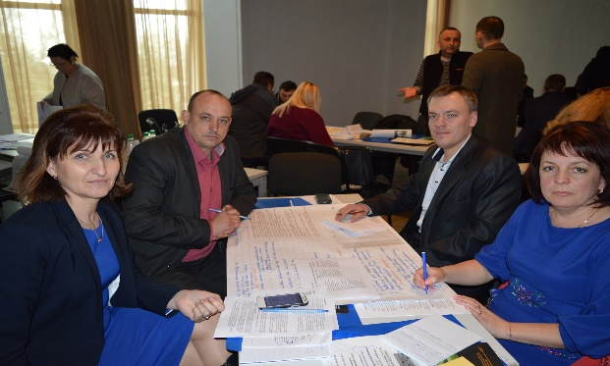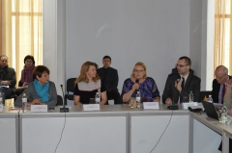

Fig1. First training of Public platforms in March in Kyiv with participation of the Dutch Embassy, Ministry and EU project that supports implementation of the MAPF Strategy 2020

- The Public Platforms are coached by NGO Primavera in composing project plans for each of the 12 projects. This methodology was mostly totally new for the Public platforms s. They are convinced now that taking project initiatives is their own responsibility and that they need to compose and communicate a professional project plan with all project partners and co-financers. NGO Primavera has informed them as well about the content and (sometimes complicated) process to find and approach co-financers. Results of these activities were as well a unique, new, transparent cooperation between local businesses and local governmental organisations, as public-private partnerships.

- The Public platforms are coached in composing a List with the main reform processes under the MAPF-Strategy, that they need the most in their local work and their 12 projects. This list is communicated by the PP’s and NGO Primavera with the relevant Department-heads and Working groups under MAPF and with representatives of the Agrarian Committee in Parliament (by having meetings with them ‘life’, and by formal letters from the NGO, on behalf of the 6 PP’s)

- Two representatives of each of the 6 Public platforms (so 12 persons), plus a representative of MAPF and Parliament member Glann have been on Study tour in the Netherlands (composed and organised by NGO Primavera), where they have met and communicated with a broad variety of stakeholders : Ukrainian Ambassador, Dutch Parliament, a LEADER-group in Province Utrecht, several experts of Dutch Enterprise Agency RVO, two different Dutch Cooperatives, several Dutch companies, active in rural development and mostly also in Ukraine (to which the PP’s have ‘pitched’ their 12 projects), representatives of the province Utrecht and a Dutch Waterboard. The 6 PP’s were impressed by the transparent cooperation and working style between Dutch stakeholders and are very motivated to apply many of those aspects in their local work and projects.

- After the Study tour it appeared that RVO was/is willing to support the 6 Public Platforms onetime in coaching and training them. Because the Matra project is relatively small and short, external support from RVO is very welcome, in addition to the coaching via NGO Primavera. In October 2016 a two-day Training is held in Kiev by RVO (financed externally under the Dutch MinEZ/RVO Memorandum of Understanding and ‘Program of Cooperation’ with MAPF) which focussed on further professional improvement of the 12 project plans by working on the (internationally ‘obligatory’) logical framework for the project plans.

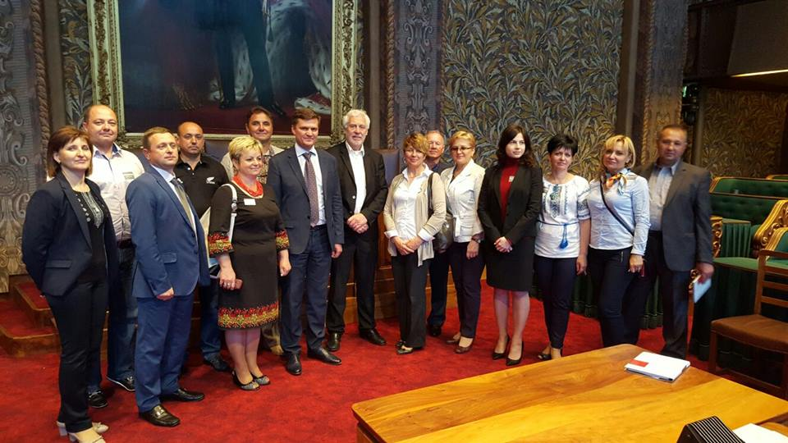
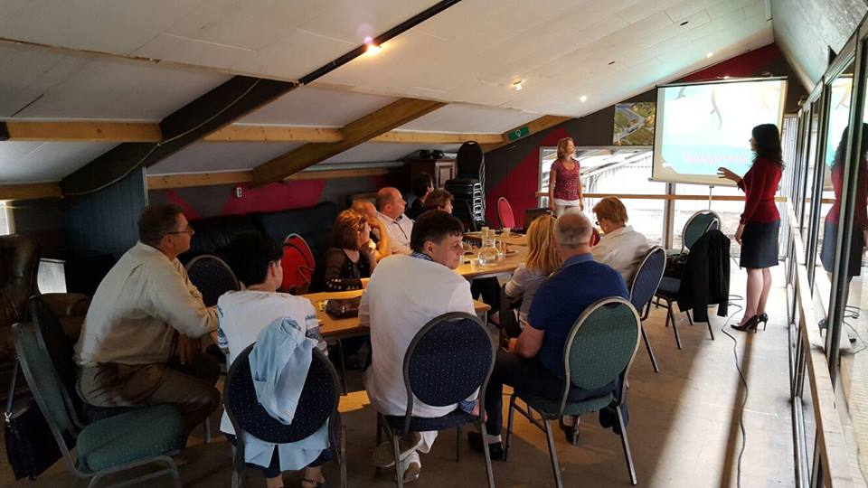

Fig. 3. Study tour meetings: from Dutch Senate to the LEADER group RD project on the local level

- After the Study tour we have proposed by letter, on behalf of the 6 PP’s, to Minister and deputy Minister of MAPF to recognise the 6 PP’s and their 12 projects as showcases of MAPF, to give them a LEADER-like status, to take the reform-proposals serious and to co-finance the 12 projects via the donor-funding, as is coordinated by MAPF. MAPF until now has reacted only formally and has not started to realise these proposals. We notice that there is still a big gap to be bridged between the top-down attitude of central authorities like a o MAPF, and the bottom-up initiatives and (reform-) proposals from the local level of the PP’s. Further support of the Dutch Embassy to the relevant deputy Minister of MAPF in bridging this gap and highlighting the Matra proposals would be very helpful.

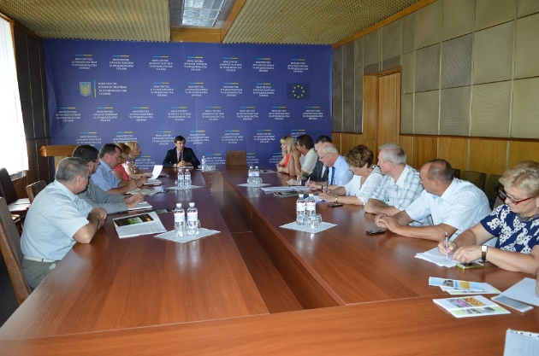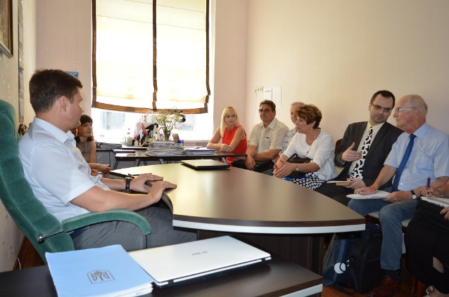

Fig.3. Monitoring of reforms and presentation of PPs recommendations during meetings with departments of MAPF and with Parliament Committee members

- NGO Primavera has communicated, on request of the PP’s, a Resume of the content of the 12 projects to several relevant MAPF-departments and -working groups, and potential co-financers. The 6 PP’s are aware that the Matra project can and may not do more than this, and that further ‘processing’ and communicating of the 12 project plans is their own responsibility. They are aware as well that this further guiding and processing of their projects is still a complicated ‘road’. Therefore the 6 PP’s, after and outside Matra, look for further consultancy to professionally guide the 6 PP’s and their 12 project plans further in finding project partners and (international) co-financers, so that the projects can be really implemented.
In autumn 2016 the 6 Public Platforms have, stimulated by the NGO but not longer guided, held their own local Matra workshops, in which they elaborated the proposals further and strengthened the local cooperation and as well strengthened the new Network between the 6 PP’s themselves.
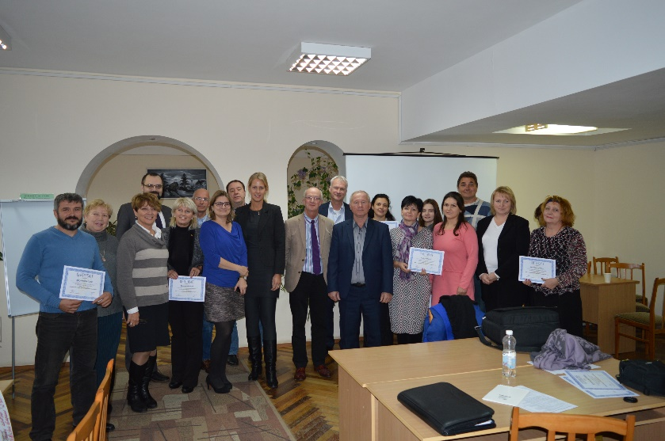

Fig 4. After additional training in October supported by the Dutch Embassy , RVO and Ministry to improve 12 project plans developed by PPs

- In the remaining project period till the Final Matra Seminar on 2017 February 22nd , the List of desirable reforms will be communicated one more time with the Agrarian Committee of Parliament, a Matra Brochure will be composed, the Matra website will be updated, and the NGO will organise (in close contact with the Dutch Embassy) the Final Matra Seminar and propose a broad list of invitations to all Oblasts , and a creative, ‘self-governing’ presentation by the 6 PP’s, to reach optimal, broad dissemination of the main Matra findings and results. These main results after Matra are : the self-governing attitude of the PP’s, the transparent style of local public-private cooperation, the proposed reforms to MAPF and Parliament, the formulated projects and the new Network between the PP’. The 6 Public Platforms will publish on the Final Seminar a common one-page OPEN LETTER to MAPF and other central organisations with their results and their concrete project requests. The Final Seminar is being organised on Wednesday morning 2017 February 22nd in Kiev.

- 10. The 6 PP’s are highly thankful to the Dutch Embassy and to MAPF about all opportunities they have received via the Matra project and the multi-sided coaching by and via NGO Primavera. Their self-believe and skills in self-governance have been increased substantially. They are convinced that they will continue their work after Matra and look for further (external) guiding and consultancy. They are developing, together with dep Minister MAPF and some Oblasts a new Project idea, called : “Territorial, integrated (Rural development) LEADER project”. This will be elaborated further by a Consortium of NGO’s, like a o GoLocal and Primavera, in cooperation with the Ukrainian Chamber of Commerce.

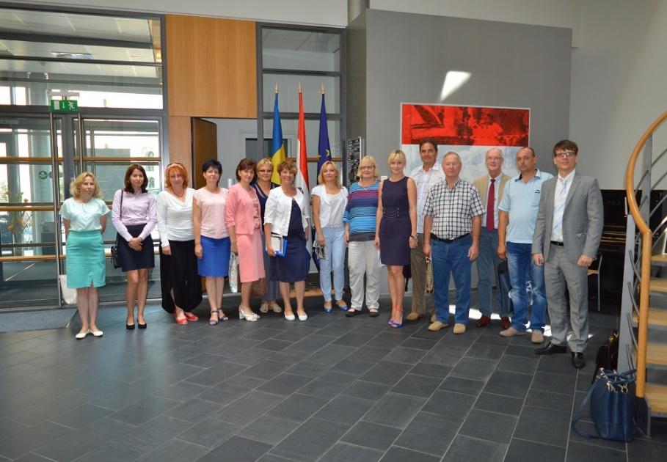

Fig.5. New energy from support and advices of the Embassy: small project, big support and new opportunities

NGO Primavera,2017 Febr 1st.

Some of Internet links with information about project activities that presented on the websites of oblast and districts administrations:

http://agrovolyn.com/news.php?id=1139
http://agrovolyn.com/news.php?id=1076
http://agrovolyn.com/news.php?id=1036
http://agrovolyn.com/news.php?id=1040
http://fastiv-region.gov.ua/content/fast%D1%96vshchina-pragne-stati-p%D1%96lotnoyu-teritor%D1%96%D1%94yu-real%D1%96zats%D1%96%D1%97-novogo-proektu-matra-believe
http://lohvica.adm-pl.gov.ua/news/robochiy-seminar-navchannya-dlya-uchasnikiv-gromadskoyi-platformi-vid-lohvickogo-rayonu-u-ramka
http://zhovkva-rda.gov.ua/index.php?option=com_content&view=article&id=10606%3A-matra-&catid=34%3Agolovna&Itemid=1
http://idbc.com.ua/news/view_post/570b6e16eb3ffe44588b586c
http://bilozerka-rda.gov.ua/content/1657

The Internet portal of the MATRA and SELF-GOVERNANCE project ,called : www.goodgovernance.org.ua is being adapted to present the new info about the of results, communications, presentation.

