This study was prepared by the expert team organized and led by of the NGO Primavera according to the personal contracts with each of the involved experts
The opinions expressed in report do not necessarily reflect the view of the European Union, the European Investment Bank, or NIRAS, and are solely in the responsibility of its authors. For details on NIRAS Policies for Privacy and Data Security follow this link: https://www.niras.com/privacy-policy/

Це дослідження було підготовлено групою експертів, організованою та очолюваною МГО Primavera згідно з особистими контрактами з кожним із залучених експертів.
Думки, висловлені у звіті, не обов’язково відображають точку зору Європейського Союзу, Європейського інвестиційного банку або NIRAS, і є виключною відповідальністю його авторів. Щоб отримати докладну інформацію про політику NIRAS щодо конфіденційності та безпеки даних, перейдіть за цим посиланням: https://www.niras.com/privacy-policy/

Acknowledgment

This report was prepared by the Ukrainian and Dutch expert team of the International non-government organization Primavera in close cooperation with UAFATA and under the guidance of the Ministry for Agrarian Policy and Food of Ukraine and the State Agency of Melioration and Fisheries. The expert team conducted an applied technical and economic study in the field of the small irrigation systems functioning under climate change within 6 regions in Ukraine where there is no occupation and no hostilities during the war. In these regions, the small local irrigation systems are still (partly) operating and playing an important role to compensate losses of agriculture production in the other regions. Farmers are interested in attracting investments to modernize and maintain these systems in the frame of the government reform of irrigation management transfer. Due to this reform, recently established Water User Organizations (WUO’s) are looking forward to organize investment projects to renovate, modernize, and enhance their irrigation infrastructure based on the principle of ‘Build back better’. The study was conducted in 6 regions and was based on the inventory data of the 166 small irrigation system. The natural, technical and economic conditions of these irrigation systems, functioning on an area of more than 330,000 ha, were analyzed taking into account water availability under climate change. For four small-scale irrigation systems that are representative for the South region and for the Central and Eastern regions of Ukraine a more detailed prefeasibility study was conducted to make an economic assessment for future investment in integrated modernization projects that combine modernization of technical infrastructure, water and agriculture management practices, alternative energy use and strengthening of the WUO’s. The cost-benefit analysis of the modern water and energy efficient solutions and sensitivity analyze of the main impacts were used to define the efficiency and sustainability of future investments. The intensive communication with local, regional and national stakeholders and visits to the pilot irrigation systems and WUO’s were organized by the expert group for data collection and development of the vision of modernization scenarios.
This report was prepared under the general coordination and editing of Olga Zhovtonog, Director of the NGO Primavera, Doctor of Science in irrigation management and Professor in agronomy in cooperation with the other expert team members: for the technical and economic issues and communication with the local stakeholders by PhD in irrigation management and irrigation systems design Vitalii Polishchuk and for irrigation management, technological and economic analysis and report organization by PhD Tetiana Matiash; for general consultations on water resource availability under climate change, institutional issues and risk analyses by PhD Mykhailo Yatsiuk; for the environmental and social assessment and general data collection by PhD Yaryna Butenko and Alla Saliuk; and for development of the GIS maps by Anatoliy Krucheniuk. High-level professional consultations on the methodology and organization of the Market study, development of the modernization scenarios, editorial work of report and support drafting of conclusions and executive summary were provided by Dutch NGO Primavera experts Koen Roest and Henk Moen.
The report also benefited a lot from the critical review and guidance from Taras Kot, the deputy head of the State Agency of Melioration and Fishery, and Angela Sharapova (Agriculture and Public Sector Capacity Building / Grain & Oilseed Value Chain Expert, Ukraine Agri-Food Value Chain TA Project). The project team also appraised a lot the support of Odesa Regional State administration by Alla Stoyanova and great cooperation with managers of water users organization and farmers: president of the WUO’s “Voda Zhittia” in Suvorovska irrigation system in Odesa region, Mykhalyna Kaparulina; Head of the WUO “Nahirnyansky Lan” from Odesa region; from WUO “ Persha” from Cherkasy region, Mykola Nalbandyan; and the contact person from Maksymivska Irrigation System, Oleg Kovalchuk. Special gratitude for the consultations and sharing of the experiences on the actual modernization projects design and implementation is owed to Sergey Ryabkov, Director of “Vodovid” Company.

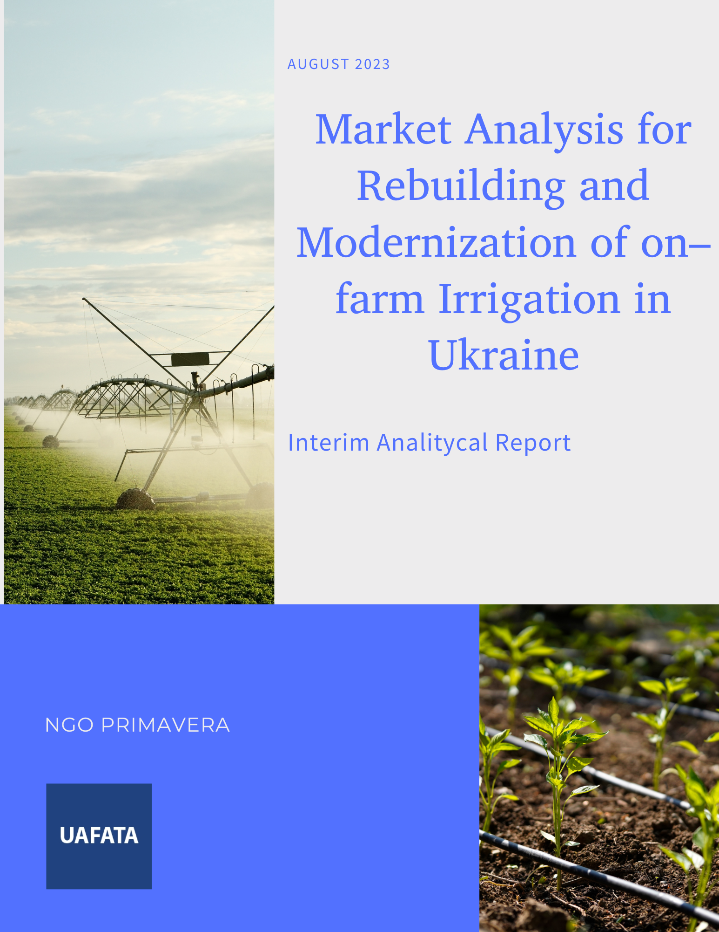
LIST OF ABBREVIATIONS

DWMD | District and Inter-district Water Management Department
DWRMD | District Water Resource Management Departments
ECL | energy consumption level
IM | irrigation machine
IS | irrigation system
MAPF | Ministry of Agrarian Policy and Food
MCMD | Main Canals Management Department
MCTD | Ministry of Communities and Territories development
ME | Ministry of Economy
MEPNR | Ministry of Environmental Protection and Natural Resources of Ukraine
MPS | main pumping station
O&M | operation and maintenance
PS | Pumping Station
PU | Pumping Unit
RBMD | River Basin Management Department
RDNA | Rapid Damage and Need Assessment
ROWRM | Regional Offices of Water Resources Management
SAMF | State Agency of Melioration and Fishery
SAWR | State Agency of Water Resources of Ukraine
SIS | Small Irrigation System
TB | Territorial bodies of SAWR (MCMD, DWMD)
TC | Territorial Community
TIDB | Technical inventory data base

A. Executive summary

Background
The Ministry for Agrarian Policy and Food of Ukraine continues with reforms in irrigation in Ukraine following the Government plan on implementation of the Irrigation and Drainage Strategy till 2030. The approved Law on Water users’ organizations at the beginning of 2021 and the recent creation of more than 30 Water User Organisations (WUO’s) in different regions in Ukraine is opening an opportunity for attracting investments for modernization, renovation and enhancing of irrigation systems in Ukraine to adapt agriculture to climate change. Sustainable agriculture production through improvement of local small irrigation systems is an important way to compensate for the production losses of the occupied areas where irrigation is no longer possible due to the destruction of the systems.

Assignment
The NGO Primavera expert team with the support of the international Technical Assistance Program 'Technical Assistance to support the implementation of the Ukraine Agri-Food Value Chain’ financed by the European Investment Bank, conducted a market study of small irrigation systems in six regions in Ukraine. This results in detailed investment plans for four selected representative irrigation systems in Odesa, Cherkasy and Poltava regions.
An integrated approach for assessment of small irrigation systems’ conditions and zoning of Ukraine was used to account for water resource availability, crops water requirements and agricultural practices under the climate change conditions as well as results of national and local damages and losses assessments of the war impacts. The project used the results of the national and local RDNA analyses supported by the World Bank.

Irrigation in Ukraine
There are two main types of irrigation systems in Ukraine: large irrigation systems that transfer water from major rivers to the farms via a complex system of long main and secondary canals and pump stations. The second type is the small local irrigation systems that take water directly from local rivers, lakes and water reservoirs.
Small irrigation systems have a smaller network of channels, shorter distances for pumping water, and are located in close proximity to the irrigation source. Accordingly, the service areas of such systems are not large. Most of the systems have an area of up to 3 000 hectares.

Irrigation challenges
Due to climate change effects of today and predictions indicate a further increase in rainfall in winter and a decrease in summer. Combined with the increase in temperature this results in an increase of crop water requirements and water deficit in summer. Surface water resource availability is reduced in summer in the majority of the regions in Ukraine. This increasing gap between water demand and water availability calls for renovation, modernization and extension of the irrigation systems to enable sustainable agriculture based on the principles of resource efficient integrated water management.
Irrigation sector reform is needed both on the level of the local private irrigation infrastructure that is being transferred now to Water User Organizations (WUO’s) as well as on the level of the large-scale state water infrastructure that delivers water to local irrigation systems. A clear definition of the roles and responsibilities of the national, regional and local stakeholders is vital to reach successful results of reform implementation and enable efficient investment projects in irrigation systems.
A main condition for investments in small irrigation systems is the presence of a clear definition of the water management infrastructure ownership. Second condition is to ensure the right of use of irrigated land within the boundaries of a complete technological module of the irrigation system. For instance the service area of a distribution channel, a pumping station or a point of water distribution on the farm. In accordance with the current legislation, the ownership right of intra-farm and inter-farm water management infrastructure and maintenance of integral technological modules of irrigation systems is going to be transferred to the WUO’s.
Due to the war 21% of the irrigated areas in the six regions considered in this report has gone out of production. Irrigation water deliveries dropped with 39% in the first year of war. The Rapid Damage and Needs Assessment (RDNA) of local irrigation systems implemented through the support of the World Bank shows, in addition to direct damages of the water infrastructure, indirect economical losses in irrigated agriculture due to the energy limitations and market logistic difficulties.
Rebuilding and modernization of the irrigation sector should be organized based on zoning of the country to account for natural conditions, technical features of the irrigation systems and assessment of the damages and needs impacts caused by the war.

Small irrigation systems
The total potential area for restoration of small irrigation systems is about 960,000 hectares. In the current project we analysed 166 irrigation systems covering a total area of 395,000 hectares, or 41% of the total potential. We selected four representative small irrigation systems based on the following characteristics that are present in the database: 1) natural climatic conditions; 2) technical features, such as irrigation water source, area served, energy efficiency, environmental conditions; and 3) organizational transformations and institutional reforms related to the operation of the irrigation systems.
Some results from the small irrigation systems data base:
- The largest number of small irrigation systems is found in the Cherkasy region.
- The irrigation water source is almost equally distributed between reservoirs, small rivers and canals and natural lakes;
- The size distribution of the small irrigation systems is skew: about 50% of the smallest systems cover only about 10% of the total area and about 10% of the largest systems cover about 50% of the area.
- High energy consuming small irrigation systems are located in the South (Dnipropetrovsk and Odesa regions) where water needs to be lifted quite high, by pump stations.
- About 20% of the 166 small irrigation systems are under reform: 26 have a registered WUO and 12 systems are planning to register in the near future.

Selection procedure
The selection of the four small pilot irrigation systems for further analysis was made in close consultations with the State Agency of Melioration and Fisheries Agency (SAMF) of Ukraine, responsible for these systems. It was decided to restrict the choice to small irrigation systems that take water from reservoirs and lakes and to avoid systems depending on small rivers and canals , which are vulnerable to climate change effects today and in the future. It was also decided to select two high energy consumption sites in the south in the semi-arid zone and two low energy consumption systems in the steppe zone further north. The last and very important criterium used was the perspective of irrigation operation by Water User Organizations for investment planning and future operation and maintenance of the system to guarantee its sustainability. The selected systems are representative in terms of technical characteristics and fit in the Agency's (SAMF) vision for the development of irrigation in Ukraine: Suvorivska irrigation system and Nagirnyanska irrigation system in the Odessa region, Trushivska irrigation system in the Cherkasy region and Maksymivska irrigation system in the Poltava region.

Methodology
For these four representative small irrigation systems, investment plans were developed, focussing not only on the infrastructure itself but also on improvement of water management technologies, implementation of environmental protection measures and introduction of innovations for profitable and sustainable irrigated agriculture and strengthening the capacities of the WUO’s. To do this in an effective way we formulated four possible future scenarios for the future development of agriculture with the following story lines:
- Laissez Faire: no irrigation, because it is not economical or WUO's do not take up their responsibility for investment, operation and maintenance;
- Business As Usual: WUO's do only the most urgently required repairs and maintenance and use the existing irrigation system;
- Green Deal: WUO's and its members introduce water and energy saving technologies;
- Jump to the Future: in addition to the Green Deal, WUO members introduce agronomic and irrigation technologies that enable climate proof farming with modern precision farming technologies, sustainable energy production and application of scientific irrigation advice.
These four scenarios have been discussed with the four WUO’s and its members and they decided which scenario they wanted to be elaborated into an investment proposal. They also decided on the cropping pattern that they want in the future and that fits the scenario selected. Based on the local climate and meteorological conditions an estimate was made of the water demand for a 90% dry year for the selected cropping pattern for each of the four pilots.
Based on the selected scenario for each of the areas, the project team made an inventory of the existing infrastructure and made an estimation what could be repaired, what needed to be upgraded and where new infrastructure would be needed. A detailed cost estimation followed this inventory to arrive at the needed investment sum.
Much existing data have been collected about the costs and the profitability of irrigation of different crops in Ukraine. Discussing these results with the WUO’s and its members in the four pilot areas resulted in selecting local economic data from practice for the current analysis instead of data derived from the existing literature. Farmers felt more confident with the results that they know than with the research results from elsewhere in Ukraine.

Results Suvorovska and Nagirnyanska irrigation systems.
The two small irrigation systems in Odesa, Suvorovska (10380 ha) and Nagirnyanska (5655 ha) require a high lifting of water up to more than 70 meter and the fourth scenario “Jump to the future” was selected. The reasoning was that the high water cost due to the lifting can be compensated by higher net benefits in agriculture by investing in precision farming technology and switching to drought sensitive high value crops.
The water source for these two systems is by lakes that are filled during high discharge periods from the Danube river. The water use of these lakes is multifunctional: irrigation, ecosystem preservation, fish breeding, and municipal water supply, water supply for the population. Actions are needed to guarantee the access of the small irrigation systems for a reliable water supply situation to prevent crop water stress.
The payback period for investments for these two systems was calculated at 10-14 years. The total investments for the integrated modernization for both the on-farm as well as the off-farm (WUO) infrastructure is about 6120 €/ha for Suvorovska and 5950 €/ha for Nagirnyanska irrigation systems. Stakeholders in both areas are committed to follow this scenario, but initially some state and/or international support will be needed as a backup for the risks that the WUO members are taking.

Results Trushivska irrigation system
The Trushivska irrigation system in the Cherkasy region (1160 ha) needs a limited lift of irrigation water up to 20 meter. It takes it water directly from the Dnipro Kremenchuk reservoir. Since the cost of irrigation water will be lower (lower energy use), the WUO and its members selected the “Green Deal” scenario for modernization. The total investment needed for both on-farm as well as off-farm (WUO) is then estimated at 5130 €/ha. This would result in a quick return of investments in about 6 years.

Results Maksymivska irrigation system
The Maksimivska irrigation system in the Poltava region (3 000 ha) needs building a new system from scratch. The water requires only a small lift of 12 meter. Costs can be reduced in this case by implementing the most flexible technical solutions in the design of irrigation infrastructure and irrigation management options. In this way elements of the “Green Deal” and “Jump to the future” scenarios were combined. The investment needed for both on-farm as well as off-farm (WUO) is then estimated at 5040 €/ha and the payback period is about 6 years.

Risks assessment
The most general risks for investments in irrigation sector on the national political arena were analyzed and a list of general economic risks are presented below:
- The price for water that WUO’s have to pay the State Operators or the Basin Water Management Departments.
- Decreases in the flow of rivers and increases in water demand for irrigation due to climate change may cause water shortages.
- Profitability of agricultural production due to the lack of markets and fluctuations in prices for agricultural products on global and local markets.
- Lack of knowledge on sustainable management of water resources at the level of WUO’s and individual farms to ensure quality service for water supply to WUO members.
- Mismatches between the agreed quality of water services by WUO’s and the price to be paid for water.
- Assessment of required additional institutional setting and training needs for Water User Organizations.
- Inability of one or more members of the WUO to pay for the water services agreed upon.

Capacity building
In order to prevent institutional management risks, it is proposed to develop a state training program for interested parties at the national, regional, and local levels. Such a program should have at least five main training modules: organizational; technical and technological; green deal principles and innovations; nature protection; and social standards.

Road map
A road map to define funding/investment options for modernization and development of small-scale irrigation systems has been developed. This road map includes three main stages (prefeasibility study; feasibility study (for smaller areas these two may be combined); creation of favourable conditions for the investor; investment agreement and start of the project. The road map that has a explicit list of activities that must be disseminated between national regional and local stakeholders.

Conclusions
Since large parts of the Southern and Eastern regions of Ukraine are occupied with no irrigation, the restoration and development of small-scale irrigation systems opens up opportunities for a significant increase in agricultural production. It may partly be compensation for the large agricultural losses in occupied areas. The potential for expansion, restoration and modernization of small irrigation systems is in total about 1 million hectares. Within the regions where market research was conducted in this project, the additional profit from projects to modernize small irrigation systems on an area of 330 000 hectares can reach up to nearly 1 billion €/year. To achieve this potential benefit, improvement of the entire practice of using irrigated land is needed. If all other regions (so up to 1 million ha) would also be covered by irrigation modernization almost all losses due to the war could be compensated.
Investments in projects of modernization or construction of new small irrigation systems served by WUO’s are appropriate if they are based on the principles of ensuring effective management of water, energy and human resources. It is essential that a good balance between the price for water and the quality of services considering the volume and timing of water supply for irrigation is struck. The quality of water services determines the extent of on-farm modernization of irrigation and other technological innovations to increase agricultural production.
The initial requirements for ensuring the efficiency of investments are the following conditions: 1) availability of the required quality and quantity of water in the irrigation source for the long term, taking into account climate change; 2) modernization and reconstruction of irrigation systems, primarily in terms of management, resource and energy conservation; 3) capacity building for the creation of economically and organizationally effective organizations of water users for the sustainable operation of irrigation systems and the organization of their modernization projects; and 4) covering the costs of operating the systems in a transparent process of forming a tariff that covers the costs of water supply services and WUO operation.

General recommendations
Regardless of the type of irrigation systems and the region of their location, all modernization investment projects should include plans for measures to minimize environmental and social risks. Such measures include the organization of a system of agro-ecological monitoring of the state of soils, irrigation water, groundwater, and the state of crops. Modern agro-ecological monitoring involves a combination of data from space images and ground observations, the results of laboratory studies of water and soil samples. Agro-ecological monitoring data, in addition to assessing impacts on the natural environment, are also used for the implementation of modern technologies for annual and operational irrigation planning, which increases resource use efficient production, ensures the rational use of water and energy resources, preservation of soil fertility and high quality of agricultural products.

.

B. Recommendations for follow-up

Given the logistic and financial limitations of the current project, it was implemented in the most optimal manner. The results in this report provide a clear indication of the profitability of irrigated agriculture in the four representative small irrigation systems investigated. There was, however, insufficient time and budget in the project for a proper repeated interaction with the Water User Organizations and its members. In a follow-up project that will be formulated and hopefully granted, the following aspects and recommendations will be worked out in more detail:
On communication: The scenarios for future agriculture will be communicated with the individual members of the WUO’s. They have to make choices to invest in their agricultural operations, based on the water supply security, availability and cost price of water. Their choices on the desired future activities, and the interaction between the members of the WUO will determine how the investment plans for the communal infrastructure will look like.
On the risks of rainfed agriculture: Especially the scenario “Laisser faire” deserves more attention. A risk analysis must be made using current local meteorological data and an estimation of future data under climate change. Obviously under rainfed conditions an extensive (low-input) method of farming will be selected with mainly drought tolerant crops. Using meteorological data and the soil moisture characteristics of the local soils the risk-analysis of harvest failure of these crops can be made. Such data and results will enable farmers to make better informative decisions on the choice between rainfed and irrigated agriculture.
On the uniformity of water cost within the WUO area: It can be expected that WUO’s decide to a differentiated price for water, depending on the lift of water and the use of energy to supply the water to the different farms. A differentiated (and more logical) price for water may lead to different preferred technology choices by WUO members and thereby may change the WUO investment plan.
On the investment plans: With the individual choices of the farmers, separate business plans will be made for the WUO members and a separate plan for the communal WUO property (inter farm network and structures). Each of these plans can than be judged by investors on taking the risk of investing.
On crop yields and crop profitability: For a better underpinning of the profitability of the defined scenarios, identification of a few pilot crops, for instance wheat, tomato, potato, sunflower and maize is recommended. For these pilot crops data on input requirement ranges, costs and crop yield ranges and price ranges for the different technology levels related to the defined scenarios will be collected and estimated. These data will be used to substantiate the identified four scenarios and will be used for the farmers’ tentative business plans. Farmers (WUO members) can then better select their best option between high investment – high risk – high profitability for the “Jump to the future” scenario and the other scenarios such as the extreme of no investment – low risk – low profitability of the “Laisser faire” scenario. This action will increase the transparency of the analyses made for the investment plan(s).
On water security: The four pilot areas analysed were selected because they are not extremely vulnerable for climate change. They have their water source in relatively large lakes and reservoirs and as relatively small water users they may have a guaranteed water supply. It is recommended to start already thinking about identifying methods to quantify the water supply situation of the other 162 small irrigation systems under climate change conditions. This is important because water security is an important criterium for selecting the technology level of farming and irrigation.

